Game Design Document

Fill up the following document

1. Write the title of your project.

“DANGEROUS DISEASE”

1. What is the goal of the game?

COLLECTING ALL THE MEDICINAL PLANTS DEFENDED BY THE ENEMIES

1. Write a brief story of your game.

A STRANGE AND DANGEROUS DISEASE HAS HIT OUR CITY AND THAT DISEASE HAS CAUGHT HOLD OF ALMOST EVERYONE IN OUR CITY, SO OUR HERO HAS TO GET 3 SPECIAL MEDICINEAL PLANTS WHICH ARE FOUND VERY RARELY,BUT IT WONT BE A CUP OF TEA AS THE MEDICINES ARE DEFENDED BY MANY ENEMIES, SO OUR HERO HAS TO PASS THEM FIRST AND THEN GET THE MEDICINE. WILL YOU HELP OUR HERO TO GET THOSE MEDICINES TO TREAT ALL THE PEOPLE OF THE CITY??

1. Which are the playing characters of this game?

* Playing characters are the ones who respond to the user based on the input from the user.
* Cars, monkeys, dinos, wizards, etc., are the playing characters in the game.

|  |  |  |
| --- | --- | --- |
| Number | Character Name | What can this character do? |
| 1 | HERO | COLLECT THE MEDICINAL PLANTS DEFENDED BY THE ENEMIES |
| 2 |  |  |
| 3 |  |  |
| 4 |  |  |
| 5 |  |  |
| 6 |  |  |
| 7 |  |  |
| 8 |  |  |

1. Which are the Non-Playing Characters of this game?

* Non-Playing characters are the ones that don't have an action or behavior when the user interacts with the game.
* Hurdles, stones, bananas, coins, etc., are non-playing characters in the game.

|  |  |  |
| --- | --- | --- |
| Number | Character Name | What can this character do? |
| 1 | ENEMY 1 | DEFEND THE MEDICINAL PLANTS |
| 2 | ENEMY2 | DEFEND THE MEDICINAL PLANTS |
| 3 | ENEMY3 | DEFEND THE MEDICINAL PLANTS |
| 4 | ENEMY4 | DEFEND THE MEDICINAL PLANTS |
| 5 | ENEMY5 | DEFEND THE MEDICINAL PLANTS |
| 6 | ENEMY6 | DEFEND THE MEDICINAL PLANTS |
| 7 |  |  |
| 8 |  |  |

Draw your imagination of this game. What does this game look like?

* Draw the game either 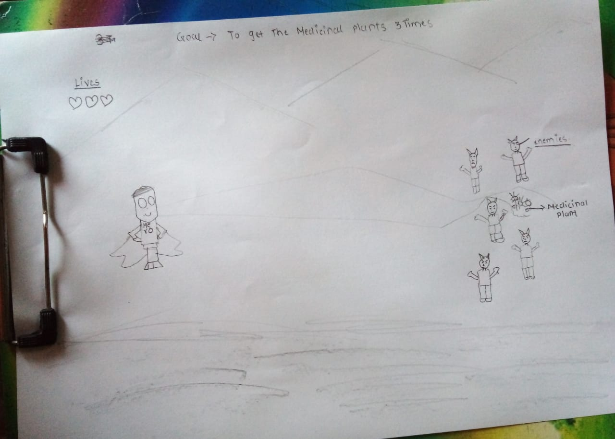 on your computer or on paper.
* Add images of the game scenes to show each of the playing and non-playing characters at least once.

How do you plan to make your game engaging?

When the Hero gets the medicinal plant at the first time it would maybe be easy but during the second time the speed of the enemies defending the Medicinal plant will increase making the game a bit harder and during the third time the speed of the enemies defending the medicinal plant will increase more than the second time so this time it will be more harder.=